**Question 1: Agent Based Modelling**

**Exercise 1.**

Questions for domain expert:

**1.** How bees forage.

Knowing how bees forage will influence how the model is modelled. This is because bees need some resources like nectar or water to survive and hence it is important to know how and where they get these resources from. We also need to know the carrying capacity and speed of the worker bees.

**2.** Environment and time steps.

Information regarding the food source/plants, and their homes/colony is required for modelling purposes; hence, we need to know about their environment. We also need to learn and model how the bees perform in alien conditions like in rain or heavy wind and then parameterize them. In addition, we need to know the time steps for studies on bees as the life span of bees is not high, and using months as timestamps might rob us of important info about bees. Too short of a time-step will convolute the model and make it complex.

**3.** Bees' natural habitat, predator, and why bees go extinct.

When modelling the environment and agents, we need to know what causes the bees to die, by either external factors or age. If external factors, what are the types, and how to parameterize them either as a distribution or a random permutation. If age, we need to model the aging due to habitat as well as climate, etc.

**4.** How different species of bees interact with other species.

As ecologist wants to connect different species of bees, we need to learn how different species interact with one another. In addition, we need to know the special traits of each bee species as different species have different characteristics and this, in turn, makes a great variability in the model output.

**5.** Bees’ reproduction, growth factor, and male bees.

When modelling the bees, we need to know what their life span is, their reproduction mechanism, and how fast the new bees grow. As we are concerned with different species of bees, we also need to model male bees, as male bees are responsible for reproduction and new species. In addition, we need to know how many eggs the queen lays at once and the ratio of male to female eggs.

**Exercise 2.**

Agents $-^{[1]}$

* Bees-

i.) Hive Bees

ii.) Foragers

iii.) Drones

iv.) Queen

Rules for agents-

* Hive Bees-

Hive bees are further classified into sub-classes consisting of juveniles, nurses and maintenance workers. Main roles of Hive bees is to oversee the bee colony and make sure it is maintain well.

* Foragers-

Forager bees are further classified into sub-classes consisting of scouts, nectar carriers and pollen carriers.

Main job of these bees is to find and get food/nectar for the bee colony/hive.

* Drones-

Drones are male bees who just stay in hive all the time and consume resources. Their sole role is to find a queen from other hives and procreate new bees.

* Queen-

The role of queen is to produce new bees. The queen decides if it wants to produce a male or a female bee.

Environment-

* Bounded and well-defend size
* Food sources like Plants, Water
* Colonies like Hives
* Pesticides and Fertilizers
* Colonies of other species

Time steps-

* Know from domain expert
* Time-step- 1 hour
* Duration- 10 years
* Spatial resolution- 1 m
* Space- 5km x 5km

Interaction-

* Hive bees remain in the Hive performing the roles assigned to them
* Drones too remain in Hive but sometimes move out of the hive in search of other queens for reproduction
* Scout bees go out in search of nectar and other resources
* Scout bees communicate the location of food to the carrier or worker bees
* The worker bees then work on producing the food for other bees in hive using the resources collected and feeding the new born, male bees.

The above-chosen parameters are sufficient to answer the questions posed by the ecologist. As the ecologist wants to connect different species of bees, our model should be concerned with knowing how the bees reproduce and how different species of bees interact. The above model designs help with modelling the food source, the different roles of different types of bees, and the male bees.

**Exercise 3.**

To know how sensitive the model output is on some parameters, we run the simulations a large number of times by changing the required parameters, while keeping the other parameters fixed.

In this case, we keep all parameters constant except the parameter-distance male bees fly from the hive in search of other queens.

This will allow us to visualise how this parameter alone causes the output to change. If there is large variability in output, we conclude that the output of the model (number of species going extinct) is highly sensitive to this parameter.

**Exercise 4.**

We compute the number of extinctions of bee species by running the model on the different types of species and lands with the different parameters and characteristics of each bee species.

As male bees play a vital role in species survival, the probability distribution of how far male bees travel, the number of new-born male bees, and how the male bees die need to be modelled and hence, there is uncertainty in the output because of these input parameters.

The best way to tackle the uncertainty in model output is to run Uncertainty Quantification. Here, we first determine the probability distribution of model output, and then look at the most important factors in the model, and finally, we analyse the difference between models in the real world.

The way to know about the important factors is to perform OFAT (One Factor At a Time) and compute how the output depends on each parameter and therefore know the important features concerning the output.

**Question 2: Equation Based Modelling**

**Exercise 1.**

$$\frac{dx(t)}{dt}=-αx\left(t\right)+ tanh⁡[{\frac{\cos\left(ωt\right)}{1+t}}]$$

**1.** The system is Non-Autonomous because the equation contains ”t” explicitly in the term- $tanh [{\frac{cos⁡(ωt)}{1+t}}]$

**2.** The iterative equation with Euler’s method is-

$$x\left(t+δt\right)=x\left(t\right)+\frac{dx(t)}{dt} δt$$

$$x\left(t+δt\right)=x\left(t\right)+(-αx\left(t\right)+ tanh⁡[{\frac{\cos\left(ωt\right)}{1+t}}]) δt$$

$$x\left(t+δt\right)=x\left(t\right)\left[1-αδt\right] + δt×tanh[{\frac{cos⁡(ωt)}{1+t}}]$$

$$x\left(t+δt\right)=x\left(t\right)\left[1-0.5δt\right] + δt×tanh[{\frac{cos⁡(5t)}{1+t}}]$$

**3.** Simulating the system with initial condition x=0 and t=0 with different $δt$.

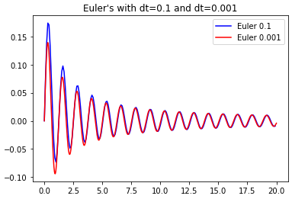

The solutions with different $δt$ are different. This is because, the slope update for each solution is different and the system with $δt=0.1$ is making bigger updates. Also, because the Local error in Eluer’s case is of order $dt^{2}$, a smaller dt means the error is smaller compared to the larger dt. Hence, the solution with $δt=0.001$ is much accurate than the solution with $δt=0.1$.

**4.** Runge-Kutta 2

The iterative equation for Runge Kutta(RK) methods is-

$$x\left(t+δt\right)=x\left(t\right)+ϕ δt$$

𝜙 varies for different Runge Kutta methods.

For RK1, $ϕ=k_{1}$, where $k_{1}$ is the slope at *t*

For RK2, $ϕ=\frac{k_{1}+k_{2}}{2}$, where $k_{1}$ is the slope at *t* and $k_{2}$ is the slope computed at $k_{1} and t+δt$.

$$x\left(t+δt\right)=x\left(t\right)+(\frac{k_{1}+k_{2}}{2}) δt$$

$$k_{1}=f(x\left(t\right),t)$$

$$k_{2}=f(x\left(t\right)+k_{1}δt,t+δt)$$

**5.** Euler’s vs RK2

Euler’s method is just RK1 where $ϕ$ equals to the slope at t. It can be seen from the graph below that RK2 produced much accurate solution than Euler’s method in spite of larger step ($δt=0.1$). 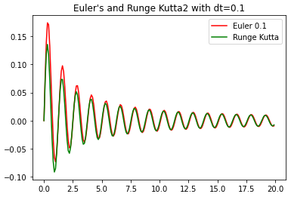

When $δt=0.001$ was choosen, the solution was much more closer as evident from the plot below 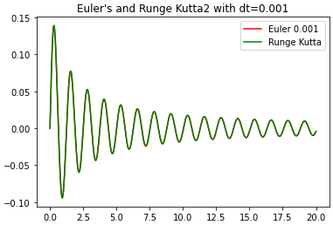

The RK2 method is much more accurate than the Euler’s method as seen from the plots. Also, the local error for Euler’s method is $dt^{2}$, while for RK2, it is $dt^{3}$, which implies a smaller error for RK2.

**Exercise 2.**

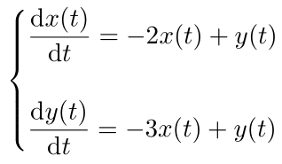

**1.** The eigenvalues are : λ1 = - 0.5 + 0.86 **i** , λ2 = - 0.5 - 0.86 **i**

The eigenvectors are : v1 = $[ \begin{matrix}0.43 - 0.25 i \\ 0.86\end{matrix} ]$ and v2 = $[ \begin{matrix}0.43+ 0.25 i \\ 0.86\end{matrix} ]$ ( where $i=\sqrt{-1}$, theunit imaginary number)

* Stability- The system is stable. It is because the Eigenvalues of the Jacobian are imaginary.
* Because the eigenvalues are imaginary, the solution has terms with sinusoidal functions and the graph looks like a spiral.
* Moreover, because the real part of eigenvalues is negative, the system spirals through the origin.
* The system goes clockwise, because at point (1,1), the direction is (-1,-2). We computed the direction by substituting x(t)=1 and y(t)=1 in the equation given in question.
* The direction (-1,-2) means that from the point (1,1), the system moves such that the change in y is twice as much as change in x and into the 3rd quadrant of the coordinate axis.

**2.** Next, the system was simulated with Euler’s method and the 3 choices for initial condition were: (1,1) , (1,-1) and (-1,1). dt=0.01 was chosen for Euler’s method.

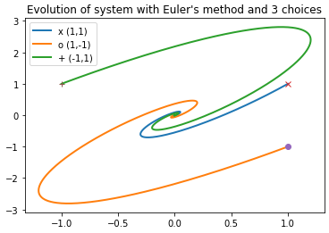

**Exercise 3.**

**1.**

Behaviour of a neuron with constant input voltage = 2 and activity reset after reaching threshold = 1.5.

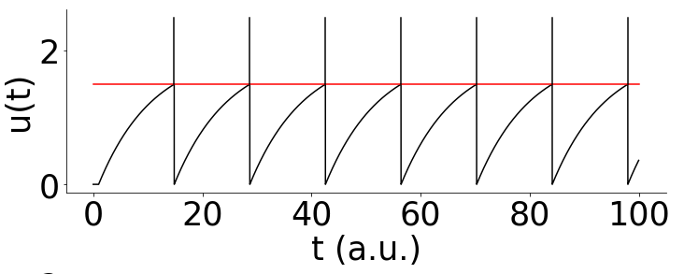

Time interval between spikes= 13.863 sec

**2.**

Values of $τ$ chosen= 10,20,30.

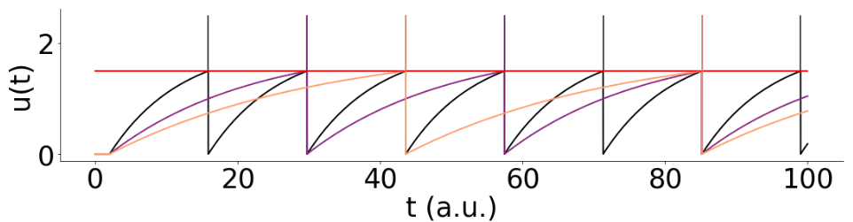

Time interval between successive spikes measured-

t= 13.863 for $τ=10$

t= 27.726 for $τ=20$

t= 41.589 for $τ=30$

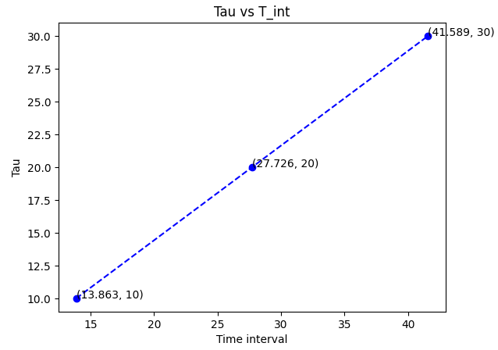

It can be seen from the plot above that the time interval for successive spikes is directly proportional to value of $τ.$

**3.**

Solving for ’t’ analytically. $I(t)=2$ as it is a constant input

$$τ\frac{dx_{i}(t)}{dt}=-x_{i}\left(t\right)+2$$

$$\int{\frac{dx_{i}\left(t\right)}{-x_{i}\left(t\right)+2}}=\int{\frac{dt}{τ}}$$

$$-\log\left(-x_{i}\left(t\right)+2\right)=\frac{t}{τ}+k$$

$$-x_{i}\left(t\right)+2=e^{-\left(\frac{t}{τ}+k\right)}$$

$$x_{i}\left(t\right)=2-k_{1}e^{-\left(\frac{t}{τ}\right)}$$

At t=0, $x_{i}=0$ (Initial condition) 🡺 🡺 = 2

$$x_{i}\left(t\right)=2(1-e^{-\left(\frac{t}{τ}\right)})$$

Solving for **“t”** from above equation

$$-e^{-\left(\frac{t}{τ}\right)}=\frac{x_{i}\left(t\right)}{2}-1$$

$$-\frac{t}{τ}=\log\left(1-\frac{x_{i}\left(t\right)}{2}\right)$$

$t=-τ\log\left(1-\frac{x_{i}\left(t\right)}{C}\right)$**(Eqn 1)**

where C is the constant voltage and log is the natural logarithm

* When $x_{i}\left(t\right)=$ 0.9, C=2 and 𝜏=10, the above equation turns into,
$$t=-10\ln\left(0.55\right)$$

$$t= -10 × -0.5978=5.978$$

* The time between successive spikes for Tau=10 and spiking threshold=0.9 is t=5.978 seconds.
* From the above equation(Eqn 1), it can be seen that time for spike is directly proportional to 𝜏. So, as in 2nd part of this question, when 𝜏 was doubled, the time interval doubled as well, and same with when it was tripled.
* When $x_{i}\left(t\right)$ = 1.5, C=2 and 𝜏=10, the above equation turns into,

$$t=-10\ln\left(0.25\right)$$

$t= -10 × -1.3863=13.863$

The t=13.86 s is the same as reported in part 1, but derived analytically.

**References:**

[1] https://www.ncbi.nlm.nih.gov/pmc/articles/PMC5371959/